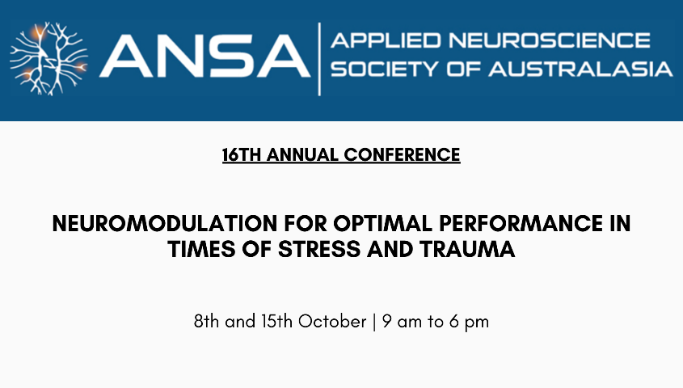

CALL FOR STUDENT ABSTRACT SUBMISSIONS

We are pleased to invite student abstract submissions for our upcoming annual conference event. This year, ANSA will provide three awards for the student presentations selected to present at the 2022 Conference, in support of promoting student involvement in the field of applied neuroscience.

ANSA would like to create a space for students to present their work in an open and supportive atmosphere. We encourage all students at both graduate and undergraduate levels to apply for these awards. Each selected submission will receive free registration to the ANSA conference for 2023 as well as the following prizes:

- 1st prize: $300
- 2nd prize: $200
- 3rd prize: $100

Abstract submissions and Early Bird Registration for the upcoming ANSA 2022 conference are now open until 1st September 2022.

We invite submissions for topics related to this year’s conference theme: Neuromodulation for Optimal Performance in Times of Stress and Trauma. We also welcome submissions related to more general topics of applied neuroscience.

Presentation types (each 20 minutes in length, plus 10 minutes of Q&A):
- Poster presentations
- Case studies

Submission Guidelines

- Abstracts must be written in English and relate to an area of applied neuroscience.
- Abstracts should be structured, using the headings: background/aims, methods, results, conclusions.
- Abstracts must not exceed 250 words (not including author/s name, affiliation or abstract title).
- Authors are advised to please proofread their abstracts before submission for grammatical and spelling errors.
- Please indicate clearly the type of presentation being submitted
- Submission of abstracts does not mean you are automatically registered for the conference. Registration for the conference is separate and will open on 15th July 2022.
- All submitted abstracts will be reviewed by members of the ANSA Conference Committee, and authors will be advised of the outcome of their submission by 15th September 2022.

For more information about our upcoming conference, please visit our website: www.appliedneuroscience.org.au

